--Cau 1

CREATE VIEW vwhangsx AS

select * from Hangsx;

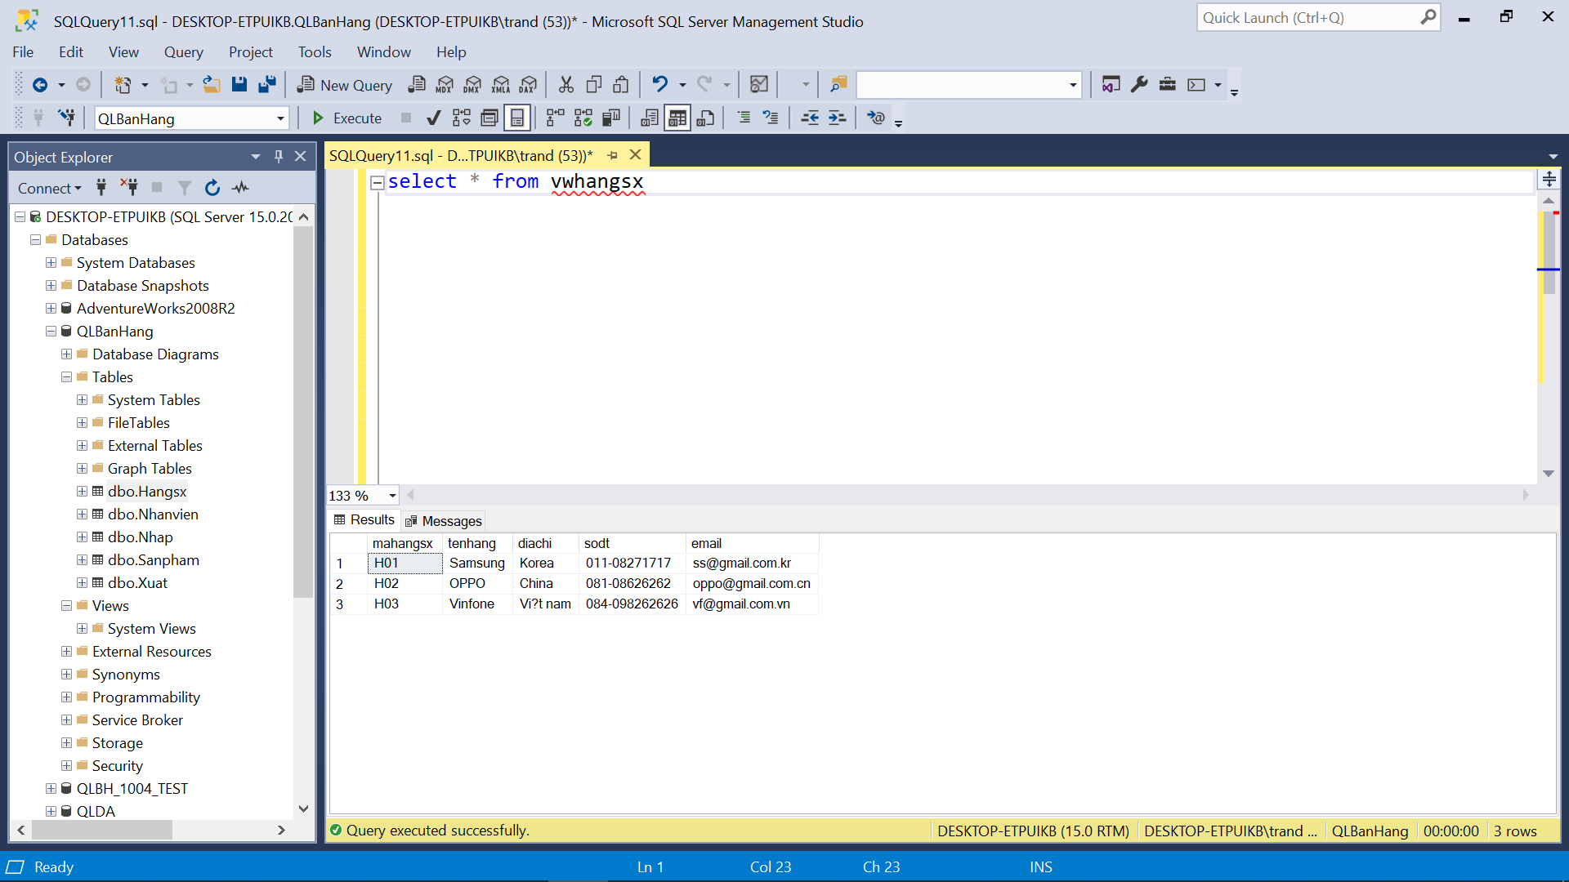

CREATE VIEW vwnhanvien AS

select * from Nhanvien;

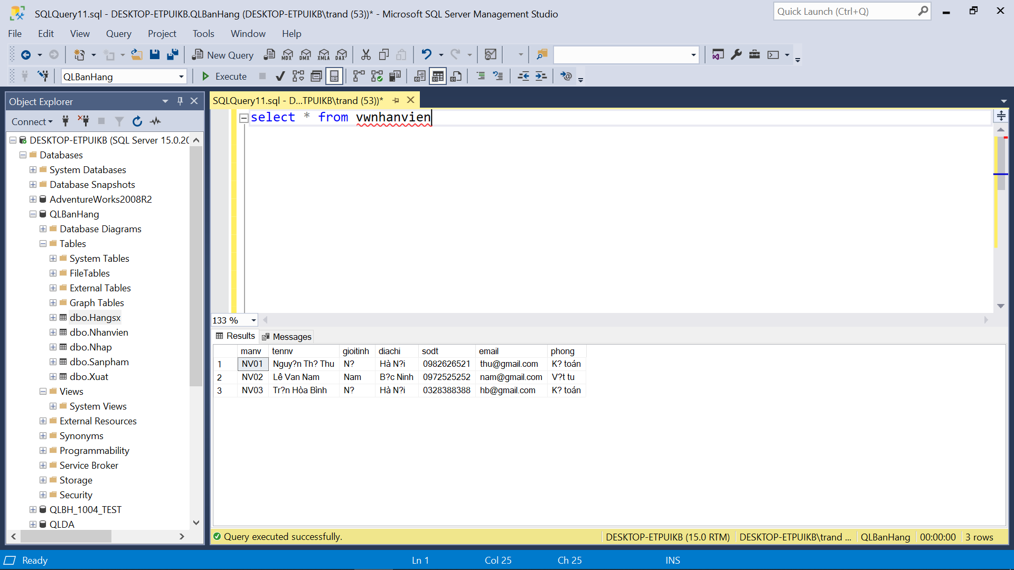

CREATE VIEW vwnhap AS

select * from Nhap;

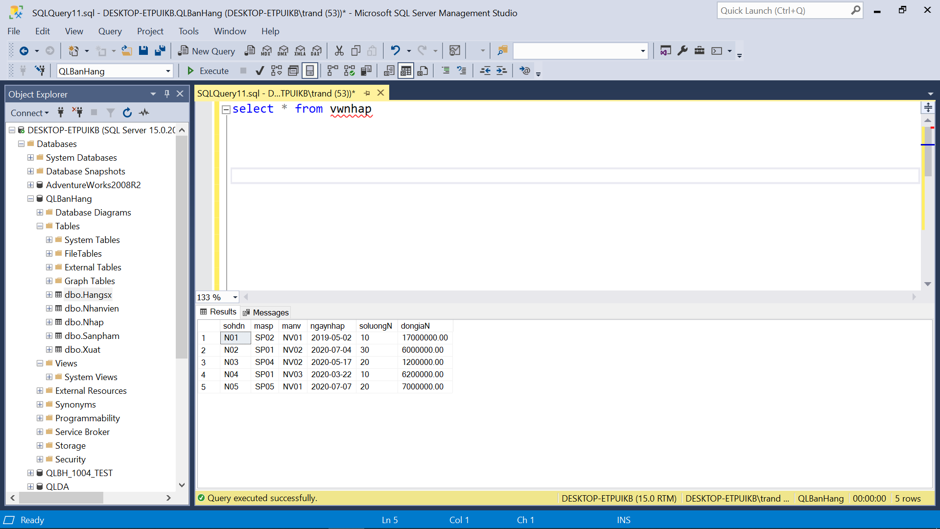

CREATE VIEW vwsanpham AS

select * from SanPham;

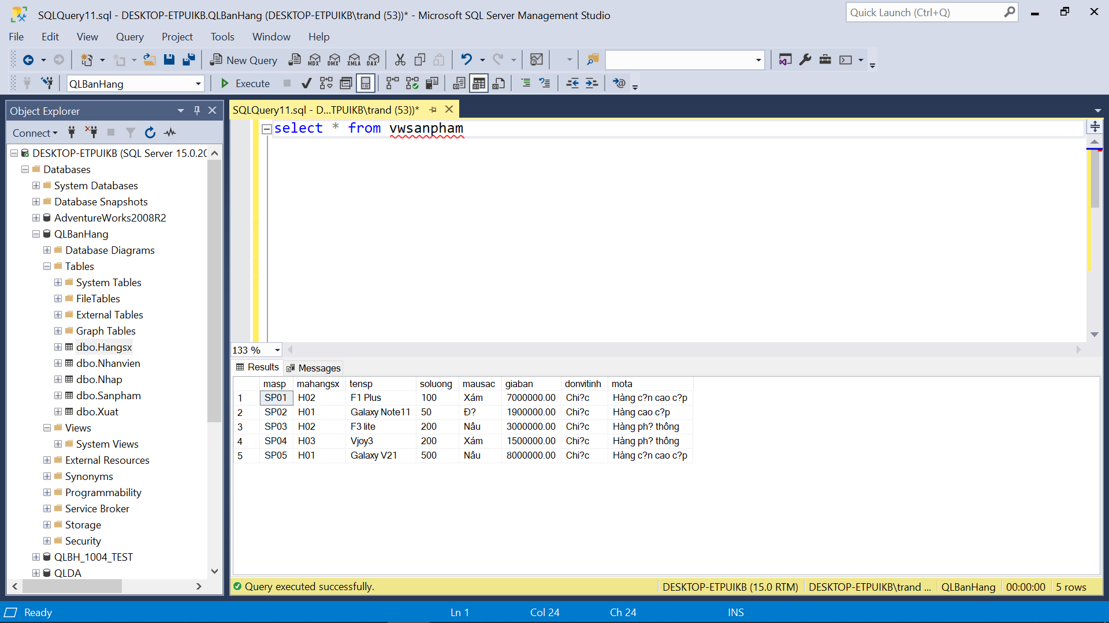

CREATE VIEW vwxuat AS

select * from Xuat;

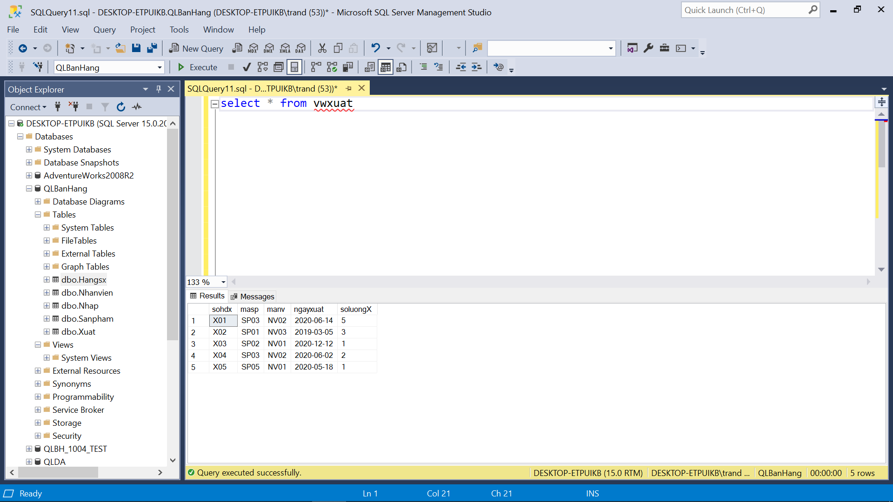

--Câu 2

CREATE VIEW cau2_lab2_1 AS

SELECT sp.masp, sp.tensp, hs.tenhang, sp.soluong, sp.mausac, sp.giaban, sp.donvitinh, sp.mota

FROM Sanpham sp

JOIN Hangsx hs ON sp.mahangsx = hs.mahangsx;

--Cau 3

CREATE VIEW cau3_lab2_1 AS

SELECT masp, tensp, tenhang, soluong, mausac, giaban, donvitinh, mota

FROM Sanpham

INNER JOIN Hangsx ON Sanpham.mahangsx = Hangsx.mahangsx

WHERE Hangsx.tenhang = 'Samsung' AND soluong > 0;

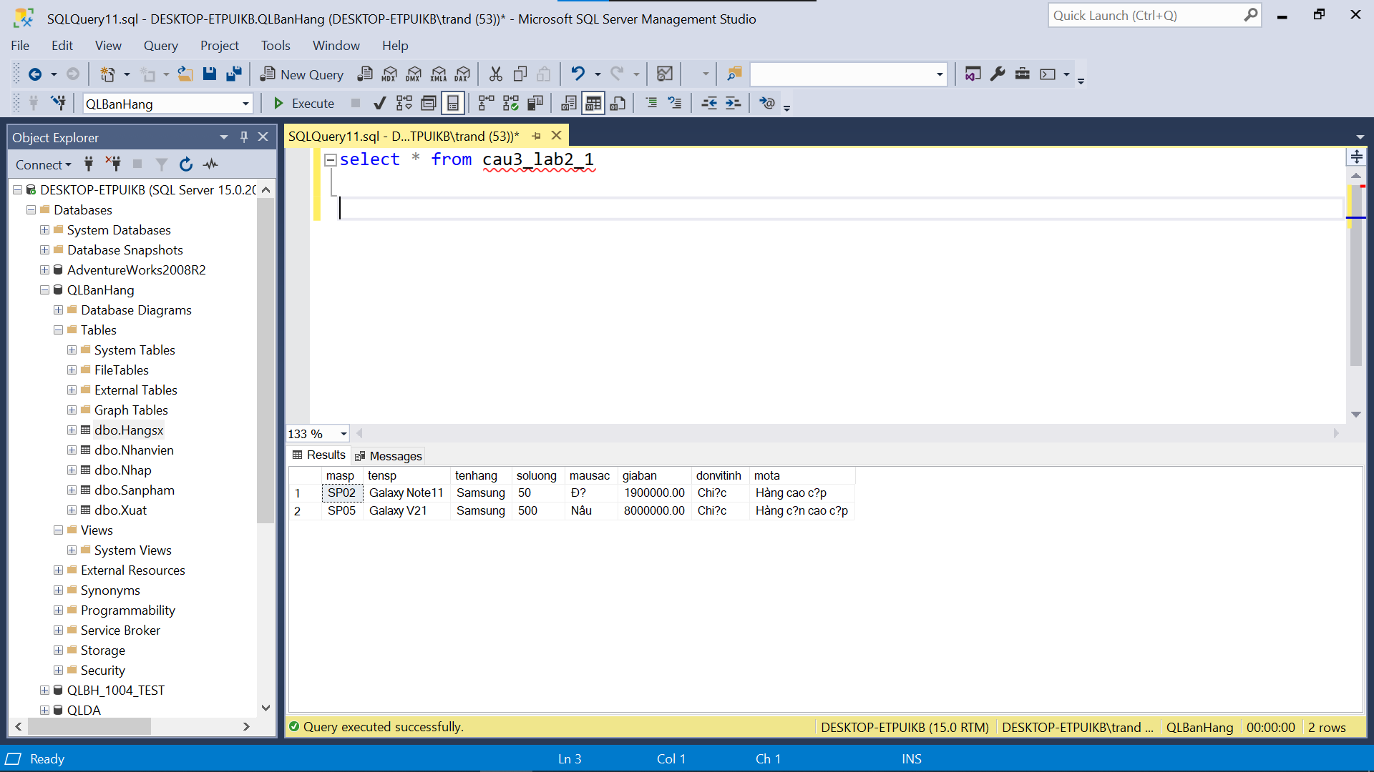

--Câu 4

CREATE VIEW cau4_lab2_1 AS

SELECT * FROM Nhanvien

WHERE gioitinh = N'N?' AND phong = N'K? toán';

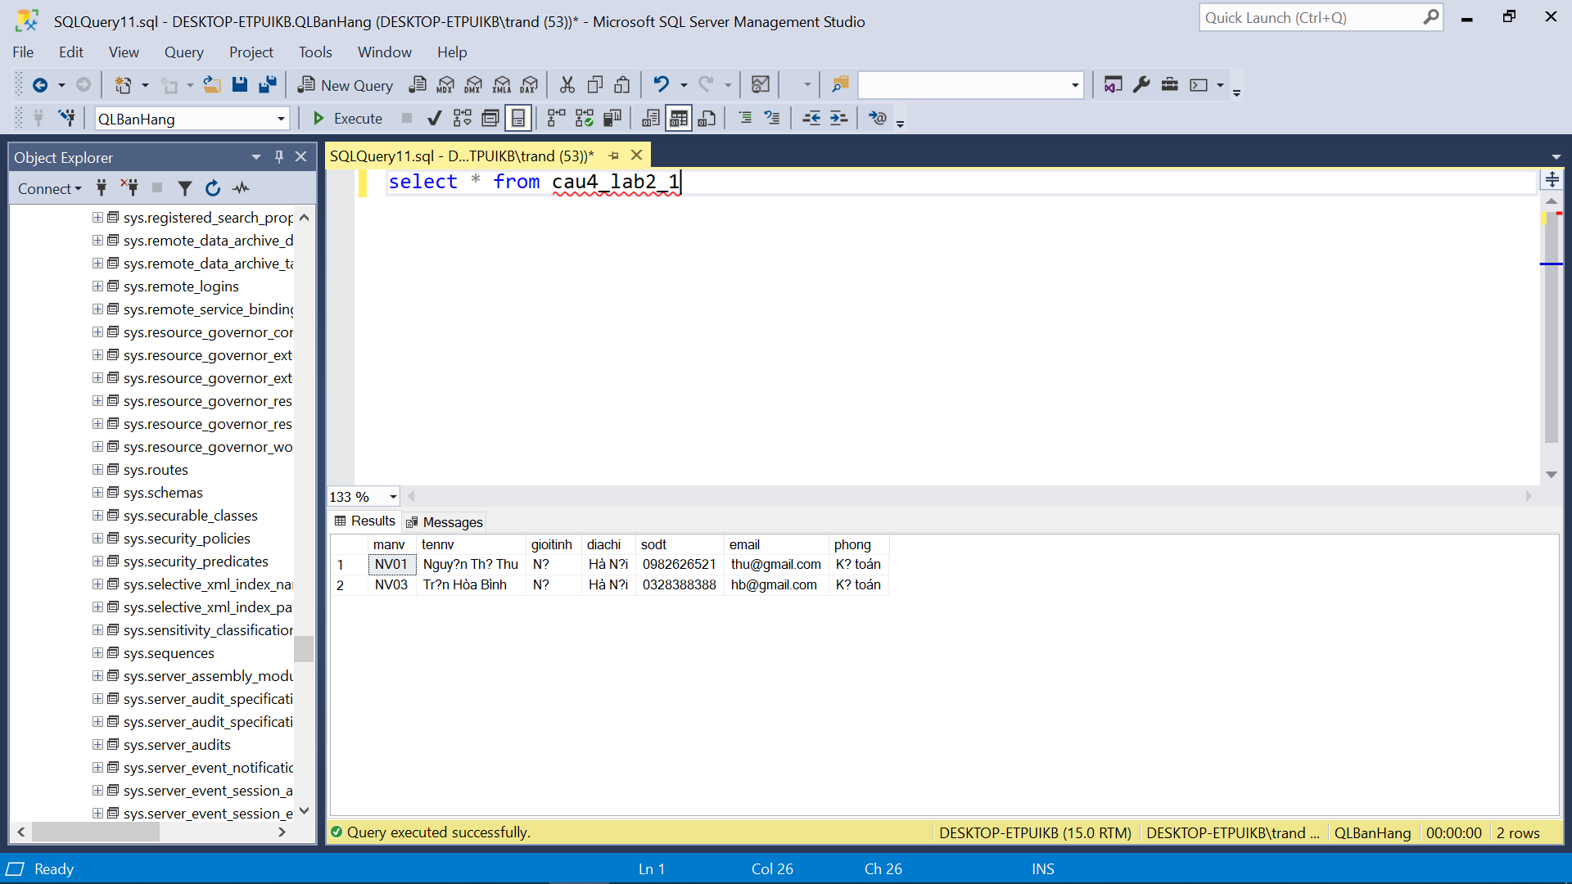

--Câu 5

CREATE VIEW cau5_lab2_1 AS

SELECT np.sohdn, sp.masp,

sp.tensp, hsx.tenhang,

np.soluongN, np.dongiaN,

np.soluongN * np.dongiaN as tiennhap,

sp.mausac, sp.donvitinh, np.ngaynhap,

nv.tennv, nv.phong

FROM Nhap np

INNER JOIN Sanpham sp ON np.masp = sp.masp

INNER JOIN Hangsx hsx ON sp.mahangsx = hsx.mahangsx

INNER JOIN Nhanvien nv ON np.manv = nv.manv

ORDER BY tiennhap ASC;

--Câu 6

CREATE VIEW cau6_lab2_1 AS

SELECT hdx.sohdx, sp.masp, sp.tensp, hsx.tenhang, hdx.soluongX, sp.giaban, (hdx.soluongX * sp.giaban) as tienxuat, sp.mausac, sp.donvitinh, hdx.ngayxuat, nv.tennv, nv.phong

FROM Xuat hdx

INNER JOIN SanPham sp ON hdx.masp = sp.masp

INNER JOIN Hangsx hsx ON sp.mahangsx = hsx.mahangsx

INNER JOIN NhanVien nv ON hdx.manv = nv.manv

WHERE MONTH(hdx.ngayxuat) = 6 AND YEAR(hdx.ngayxuat) = 2020

ORDER BY hdx.ngayxuat ASC

OFFSET 0 ROWS;

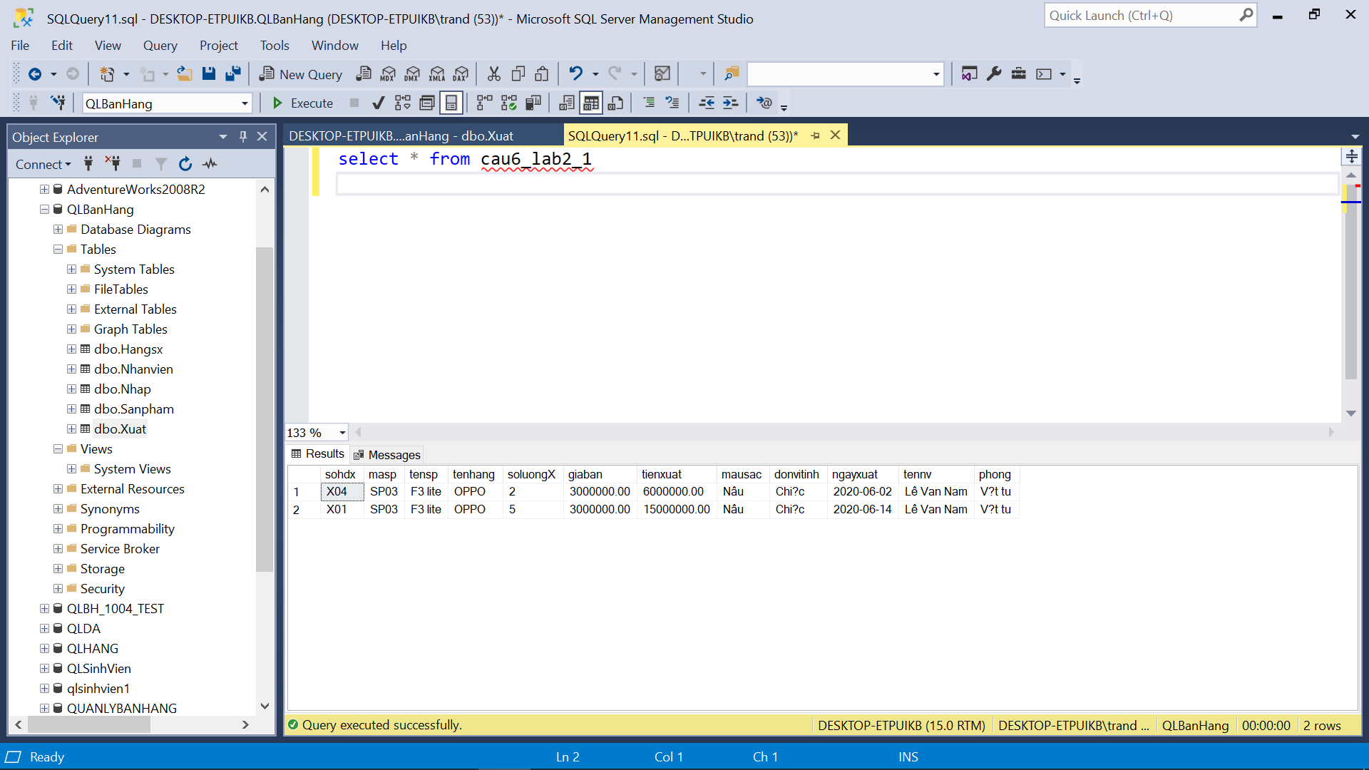

--Câu 7

CREATE VIEW cau7_lab2_1 AS

SELECT N.sohdn, N.masp, S.tensp, N.soluongN, N.dongiaN, N.ngaynhap, NV.tennv, NV.phong

FROM Nhap N

JOIN Sanpham S ON N.masp = S.masp

JOIN Nhanvien NV ON N.manv = NV.manv

JOIN Hangsx H ON S.mahangsx = H.mahangsx

WHERE YEAR(N.ngaynhap) = 2020 AND H.tenhang = 'Samsung';

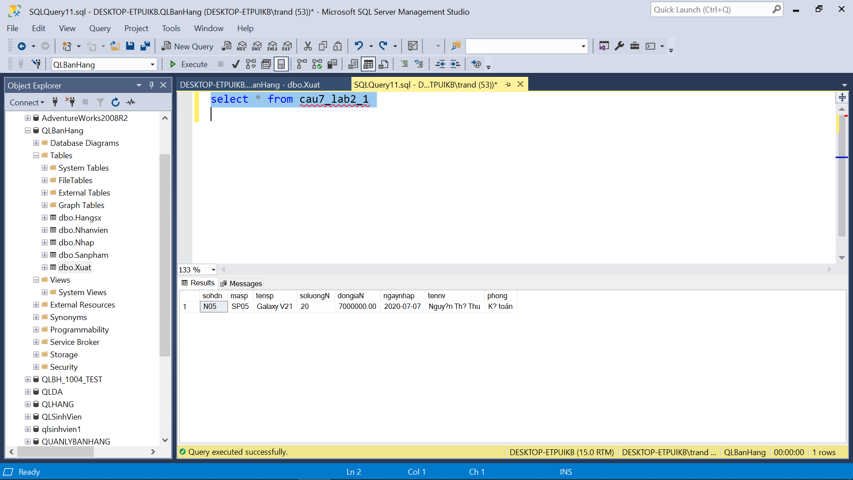

--Câu 8

CREATE VIEW cau8_lab2_1 AS

SELECT TOP 10 Xuat.sohdx, SanPham.tensp, Xuat.soluongX

FROM Xuat

INNER JOIN SanPham ON Xuat.masp = SanPham.masp

WHERE YEAR(Xuat.ngayxuat) = 2020

ORDER BY Xuat.soluongX DESC;

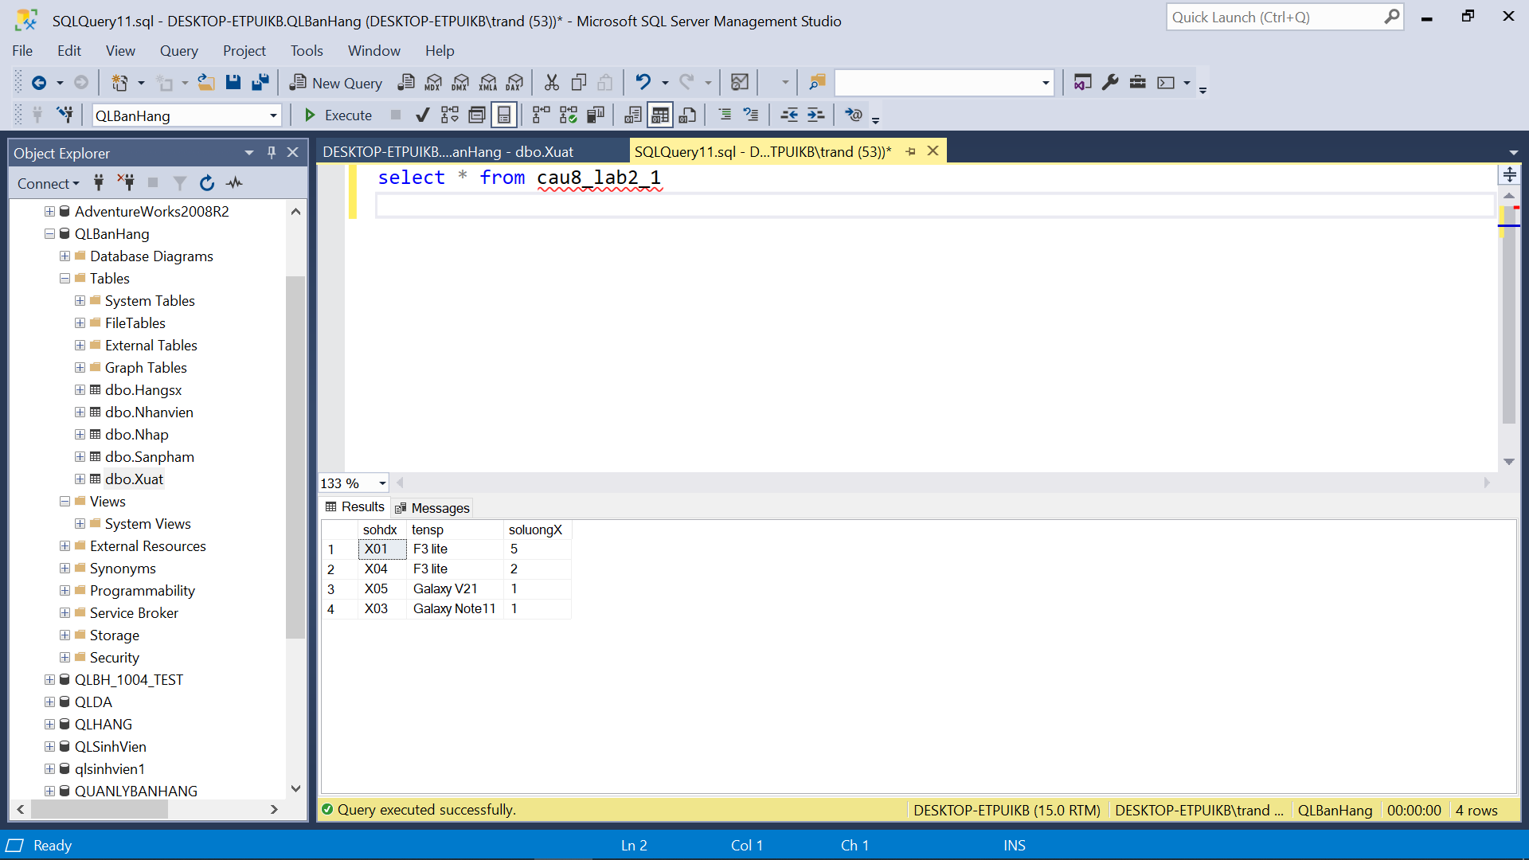

--Câu 9

CREATE VIEW cau9_lab2_1 AS

SELECT TOP 10 SanPham.masp, SanPham.tensp, SanPham.giaban

FROM SanPham

ORDER BY SanPham.giaban DESC;

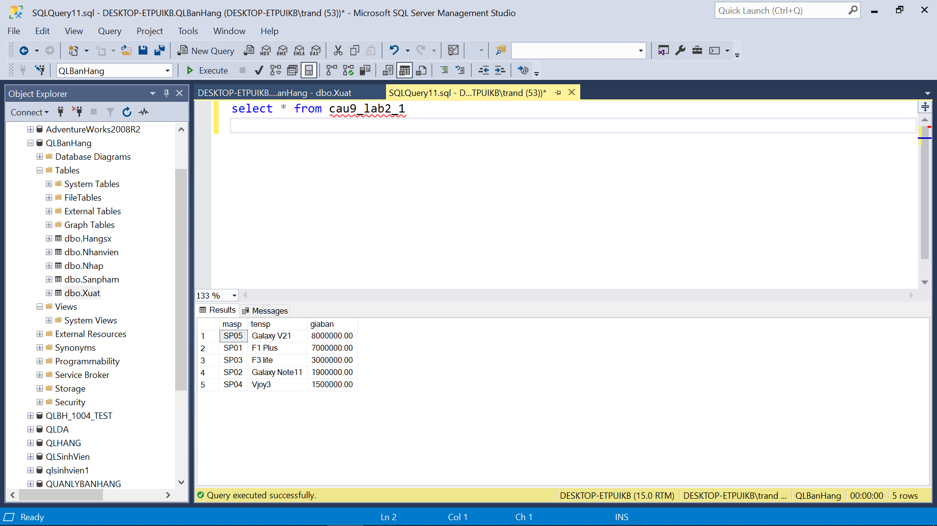

--Câu 10

CREATE VIEW cau10_lab2_1 AS

SELECT Sanpham.masp, Sanpham.tensp, Sanpham.giaban, Sanpham.donvitinh, Hangsx.tenhang

FROM Sanpham

INNER JOIN Hangsx ON Sanpham.mahangsx = Hangsx.mahangsx

WHERE Hangsx.tenhang = 'Samsung' AND Sanpham.giaban >= 100000 AND Sanpham.giaban <= 500000;

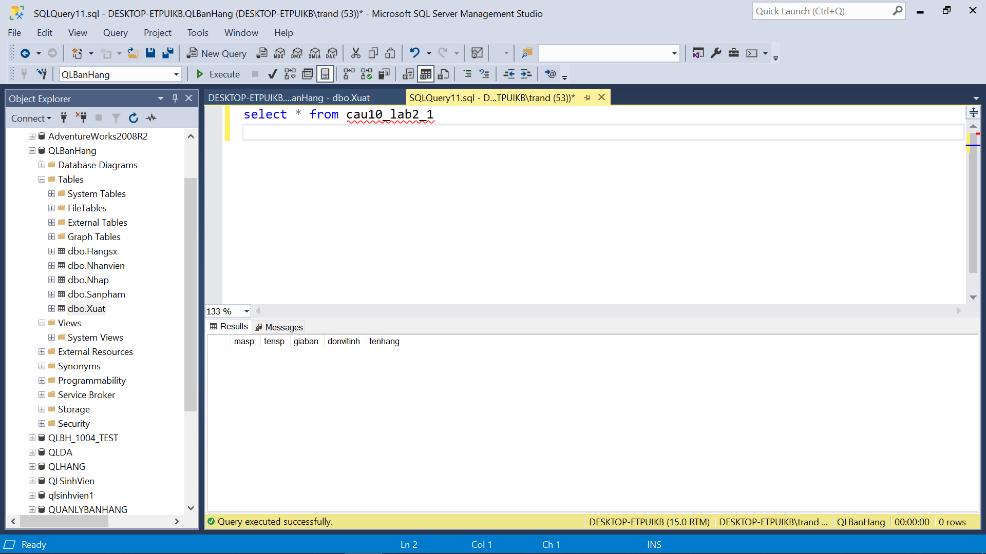

--Câu 11

CREATE VIEW cau11_lab2_1 AS

SELECT SUM(Nhap.soluongN * SanPham.giaban) AS TongTienNhap

FROM Nhap

JOIN SanPham ON Nhap.masp = SanPham.masp

JOIN Hangsx ON SanPham.mahangsx = Hangsx.mahangsx

WHERE Hangsx.tenhang = 'Samsung' AND YEAR(Nhap.ngaynhap) = 2020;

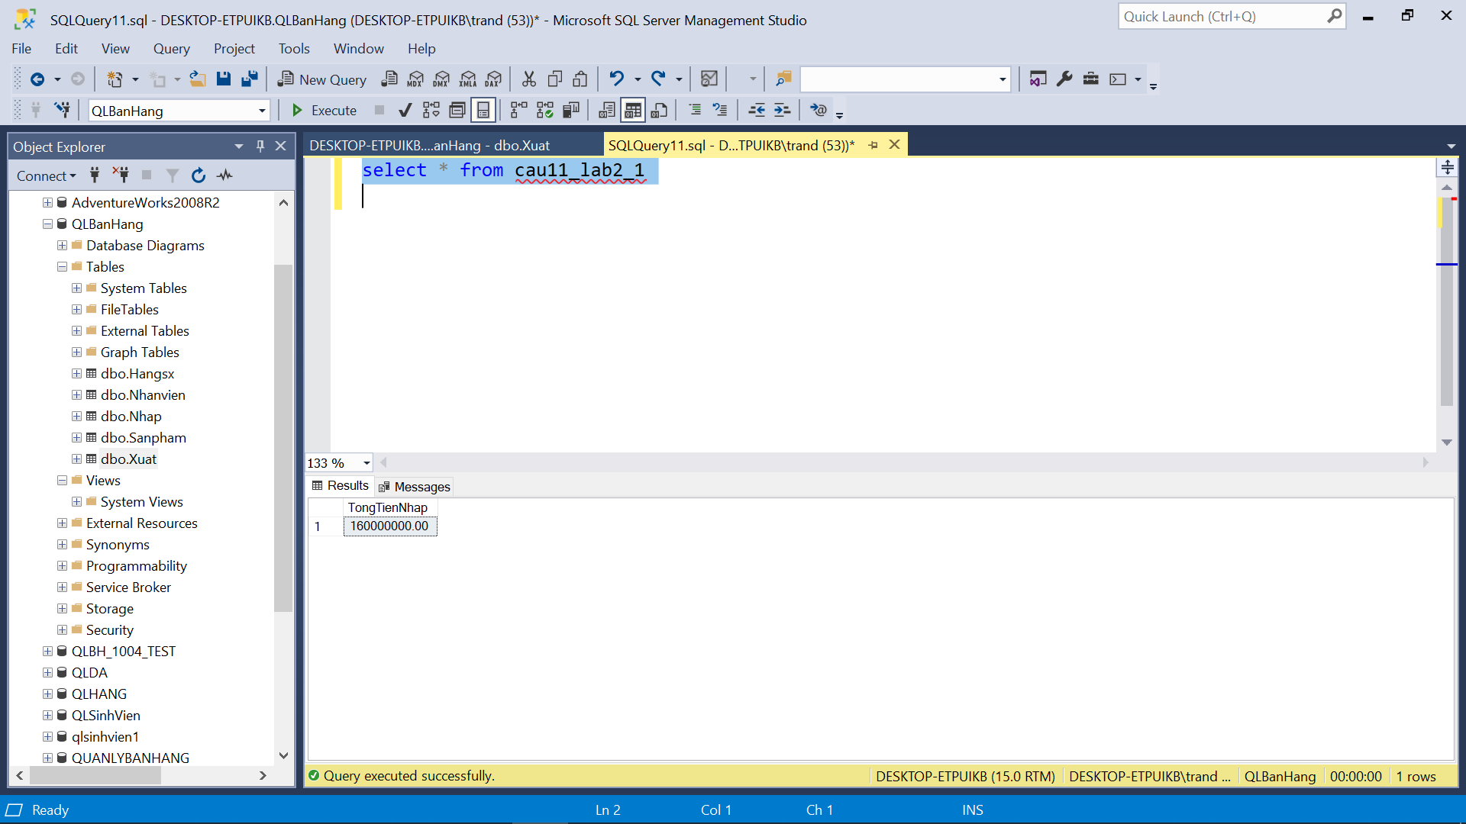

--Câu 12

CREATE VIEW cau12_lab2_1 AS

SELECT SUM(Xuat.soluongX * SanPham.giaban) AS TongTienXuat

FROM Xuat

JOIN SanPham ON Xuat.masp = SanPham.masp

WHERE Xuat.ngayxuat = '2020-06-14'

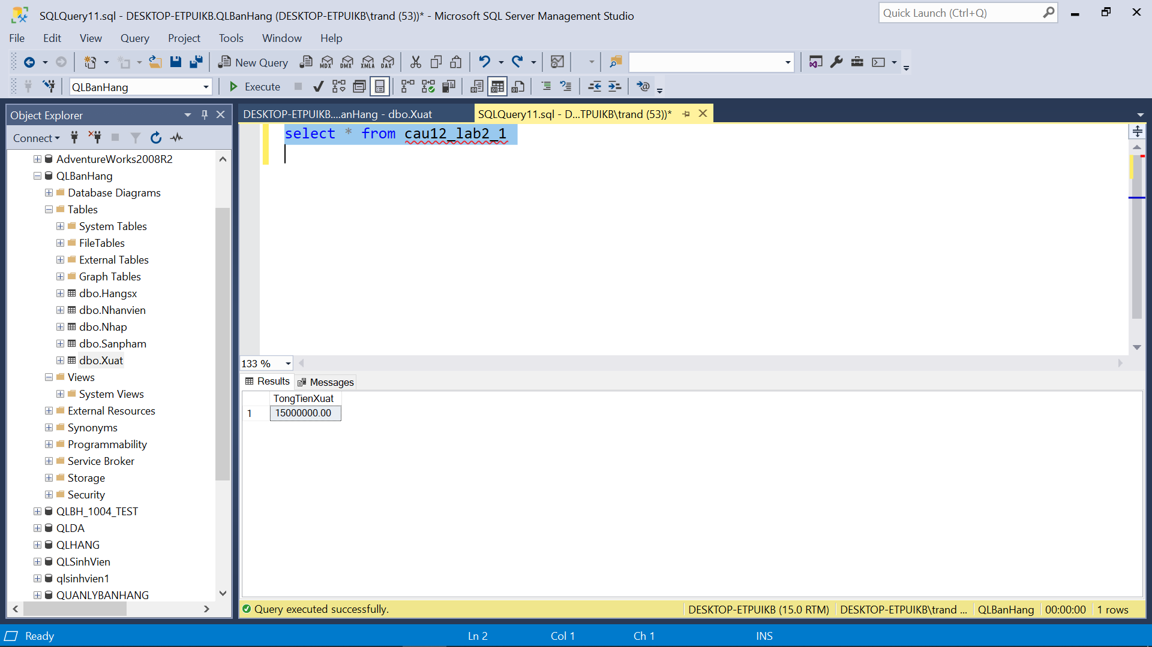

--Câu 13

CREATE VIEW cau13_lab2_1 AS

SELECT top 1 sohdn, ngaynhap

FROM Nhap

WHERE YEAR(ngaynhap) = 2020

ORDER BY soluongN * dongiaN DESC

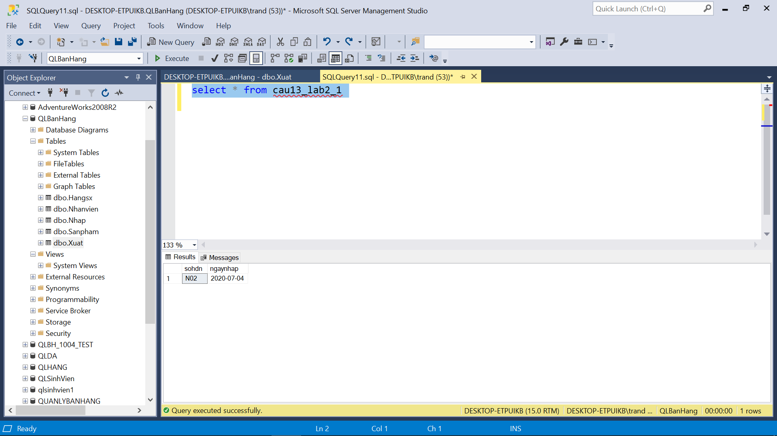

--Câu 14

CREATE VIEW cau14_lab2_1 AS

SELECT TOP 10 SanPham.tensp, SUM(Nhap.soluongN) AS TongSoLuongNhap

FROM Nhap

JOIN SanPham ON Nhap.masp = SanPham.masp

WHERE YEAR(Nhap.ngaynhap) = 2019

GROUP BY SanPham.tensp

ORDER BY SUM(Nhap.soluongN) DESC

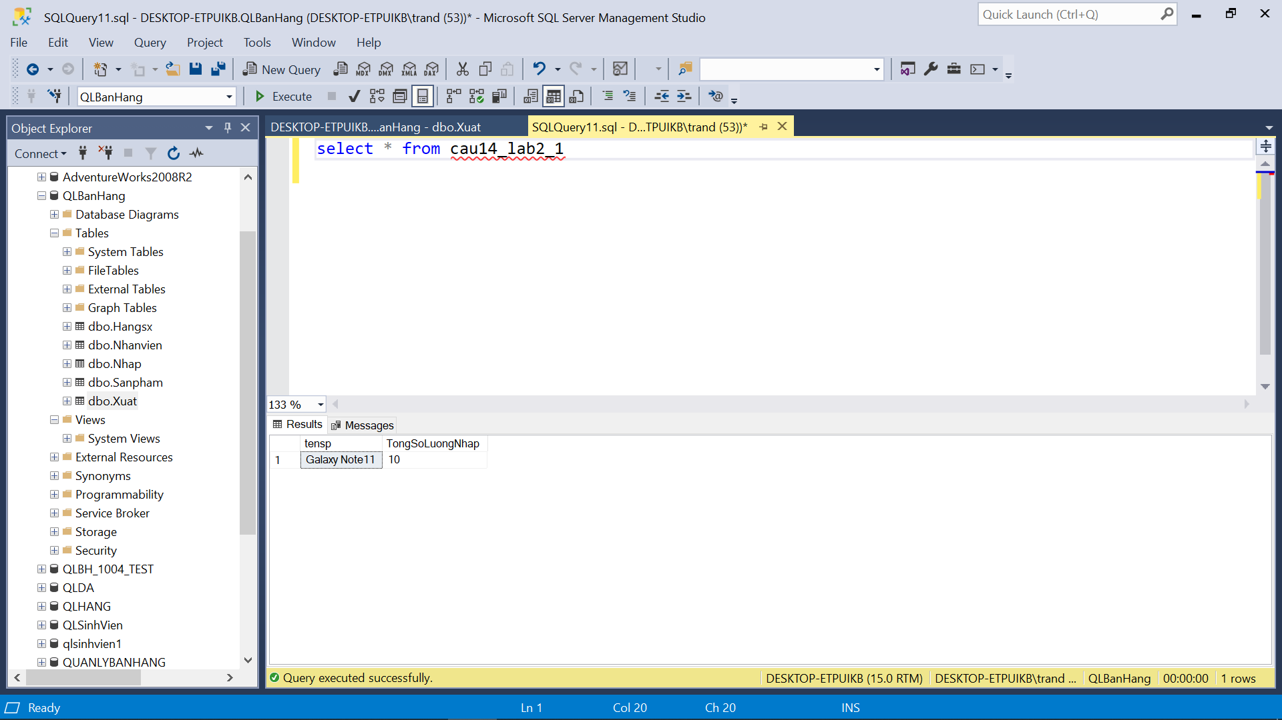

--Câu 15

CREATE VIEW cau15_lab2_1 AS

SELECT SanPham.masp, SanPham.tensp

FROM Nhap

JOIN SanPham ON Nhap.masp = SanPham.masp

JOIN Hangsx ON SanPham.mahangsx = Hangsx.mahangsx

JOIN NhanVien ON Nhap.manv = NhanVien.manv

WHERE Hangsx.tenhang = 'Samsung' AND NhanVien.manv = 'NV01'

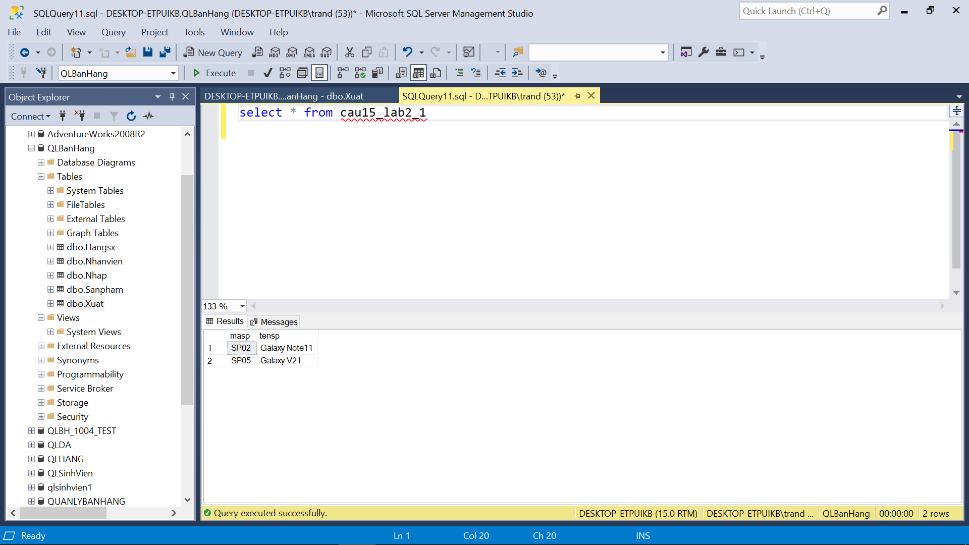

--Câu 16

CREATE VIEW cau16_lab2_1 AS

SELECT Nhap.sohdn, Nhap.masp, Nhap.soluongN, Nhap.ngaynhap

FROM Nhap

JOIN Xuat ON Nhap.masp = Xuat.masp AND Nhap.sohdn = Xuat.sohdx

WHERE Nhap.masp = 'SP02' AND Xuat.manv = 'NV02';

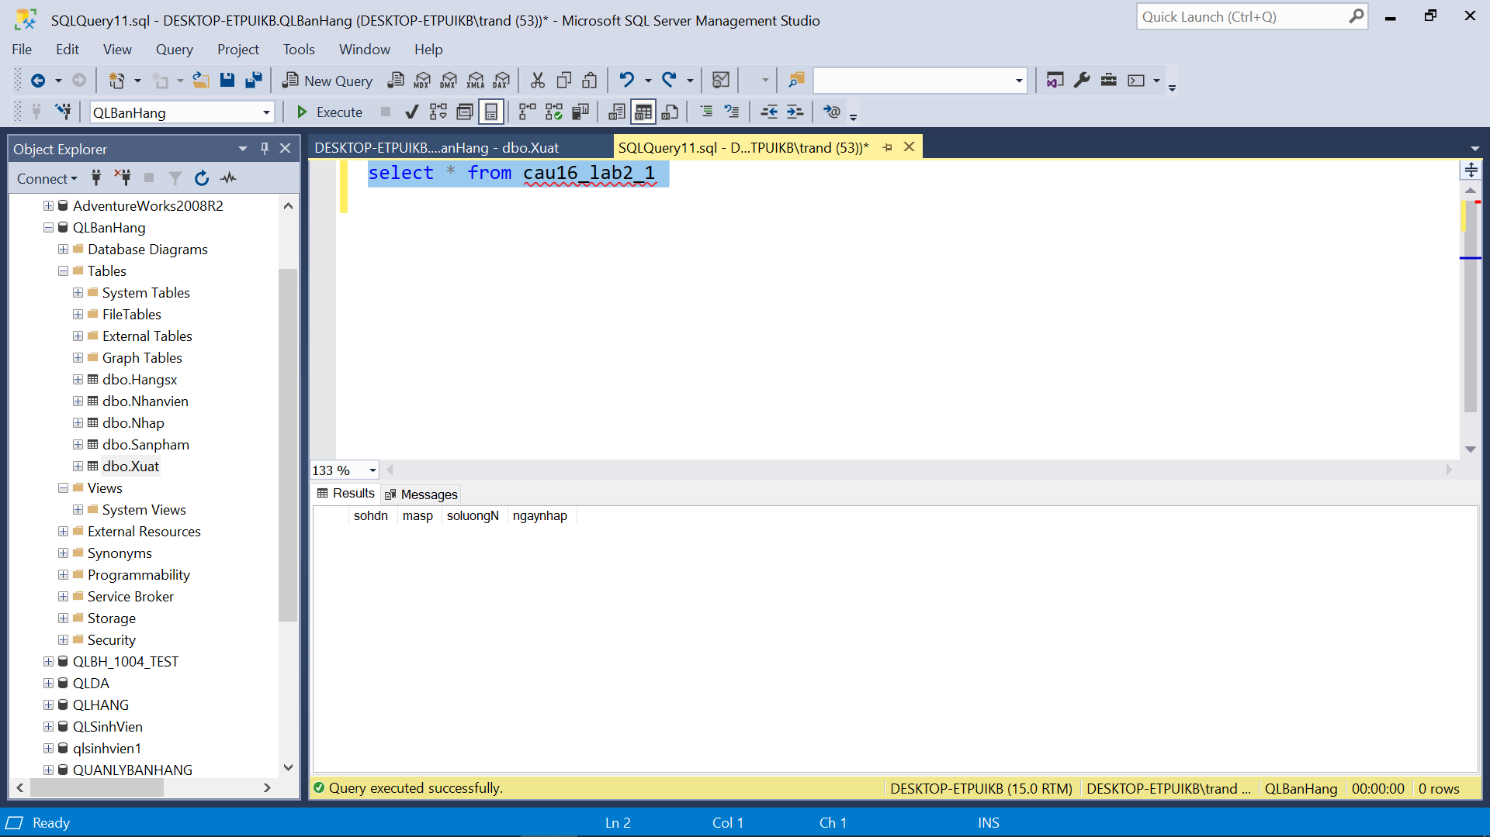

--Câu 17

CREATE VIEW cau17_lab2_1 AS

SELECT Nhanvien.manv, Nhanvien.tennv

FROM Nhanvien

JOIN Xuat ON Nhanvien.manv = Xuat.manv

WHERE Xuat.masp = 'SP02' AND Xuat.ngayxuat = '2020-03-02';

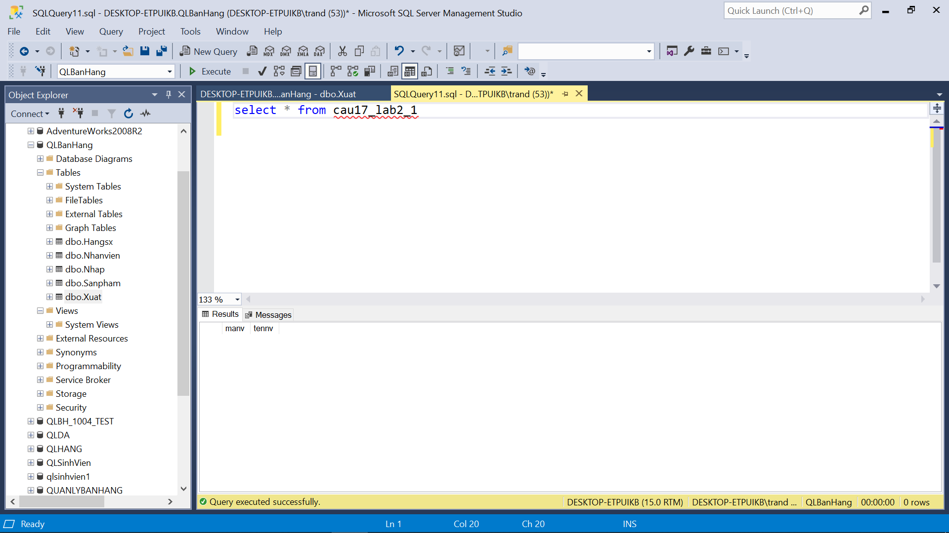

--Câu 18

CREATE VIEW cau18_lab2_2 AS

SELECT hsx.tenhang, COUNT(sp.masp) AS N'SoLoaiSP'

FROM Sanpham sp

INNER JOIN Hangsx hsx ON sp.mahangsx = hsx.mahangsx

GROUP BY hsx.tenhang

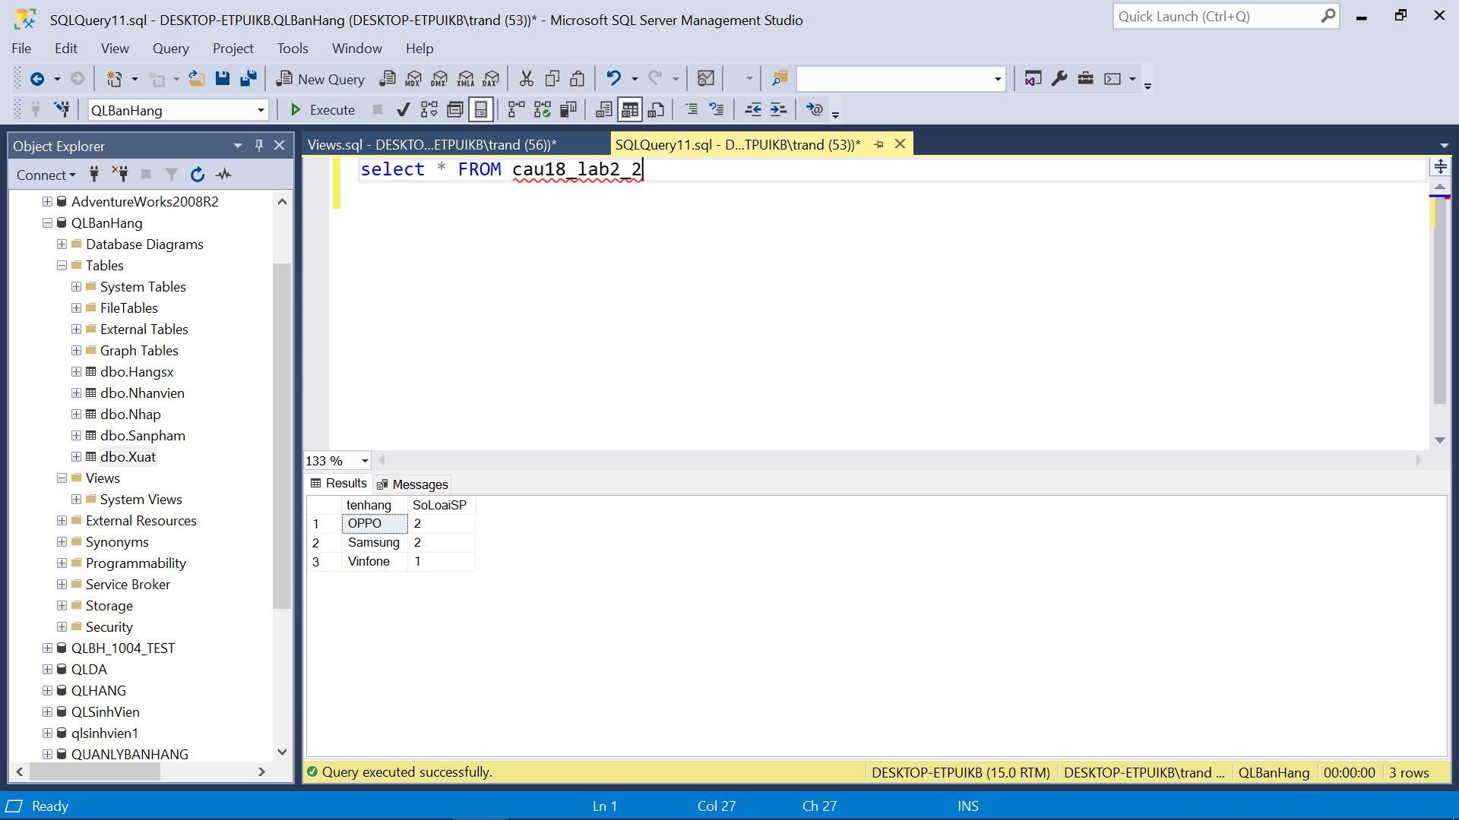

--Câu 19

CREATE VIEW cau19_lab2_2 AS

SELECT sp.masp, sp.tensp, SUM(np.soluongN * np.dongiaN) AS tongtien

FROM Nhap np

INNER JOIN Sanpham sp ON np.masp = sp.masp

WHERE YEAR(np.ngaynhap) = 2018

GROUP BY sp.masp, sp.tensp

--Câu 20

CREATE VIEW cau20_lab2_2 AS

SELECT TOP 100 sp.masp, sp.tensp, SUM(x.soluongX) AS TongSoLuongXuat

FROM SanPham sp

INNER JOIN Xuat x ON sp.masp = x.masp

INNER JOIN Hangsx hsx ON sp.mahangsx = hsx.mahangsx

WHERE YEAR(x.ngayxuat) = 2018 AND hsx.tenhang = 'Samsung'

GROUP BY sp.masp, sp.tensp

HAVING SUM(x.soluongX) > 10000

ORDER BY TongSoLuongXuat DESC

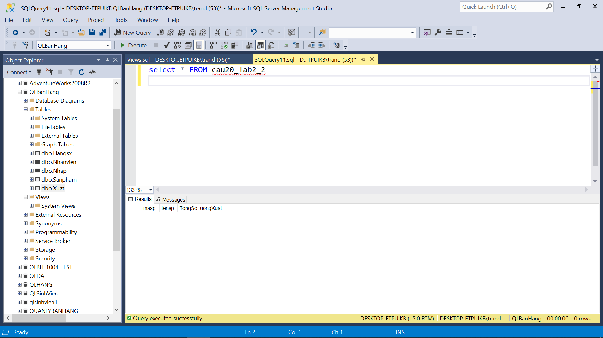

--Câu 21

CREATE VIEW cau21_lab2_2 AS

SELECT phong, COUNT(*) AS soluong_nam

FROM NhanVien

WHERE gioitinh = N'Nam'

GROUP BY phong

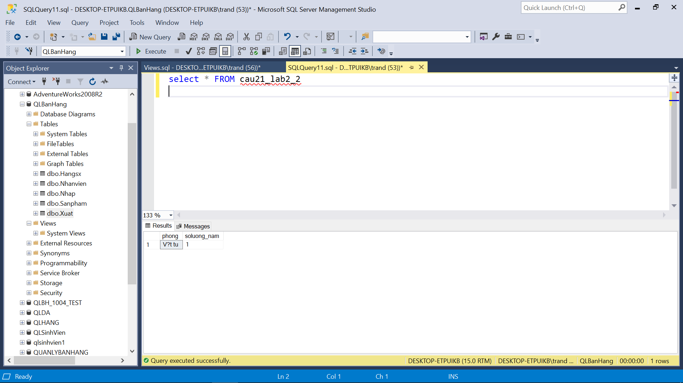

--Câu 22

CREATE VIEW cau22_lab2_2 AS

SELECT hsx.tenhang, SUM(np.soluongN) AS tong_soluong_nhap

FROM Hangsx hsx JOIN Sanpham sp ON hsx.mahangsx = sp.mahangsx

JOIN Nhap np ON sp.masp = np.masp

WHERE YEAR(np.ngaynhap) = 2018

GROUP BY hsx.tenhang

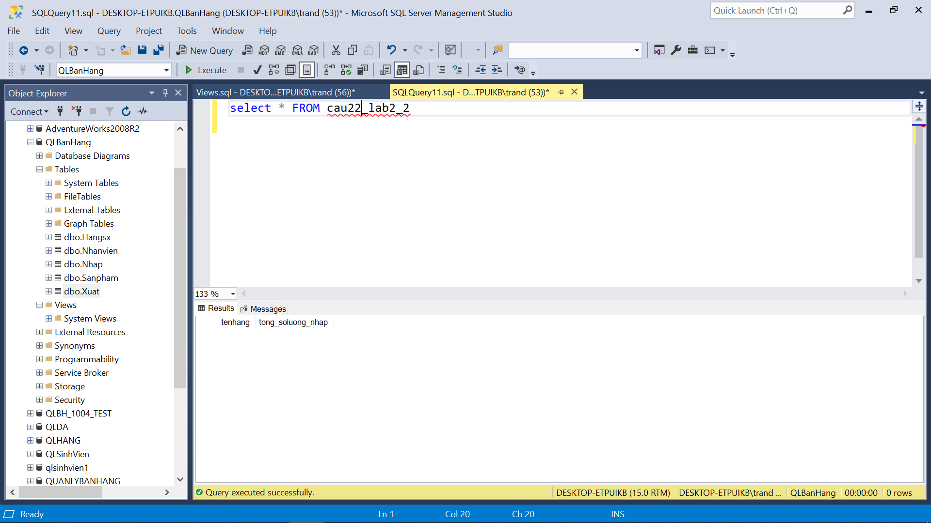

--Câu 23

CREATE VIEW cau23_lab2_2 AS

SELECT nv.manv, nv.tennv, SUM(soluongX * giaban) AS tong_tien_xuat

FROM Xuat x

JOIN SanPham sp ON x.masp = sp.masp

JOIN NhanVien nv ON x.manv = nv.manv

WHERE YEAR(ngayxuat) = 2018

GROUP BY nv.manv, nv.tennv

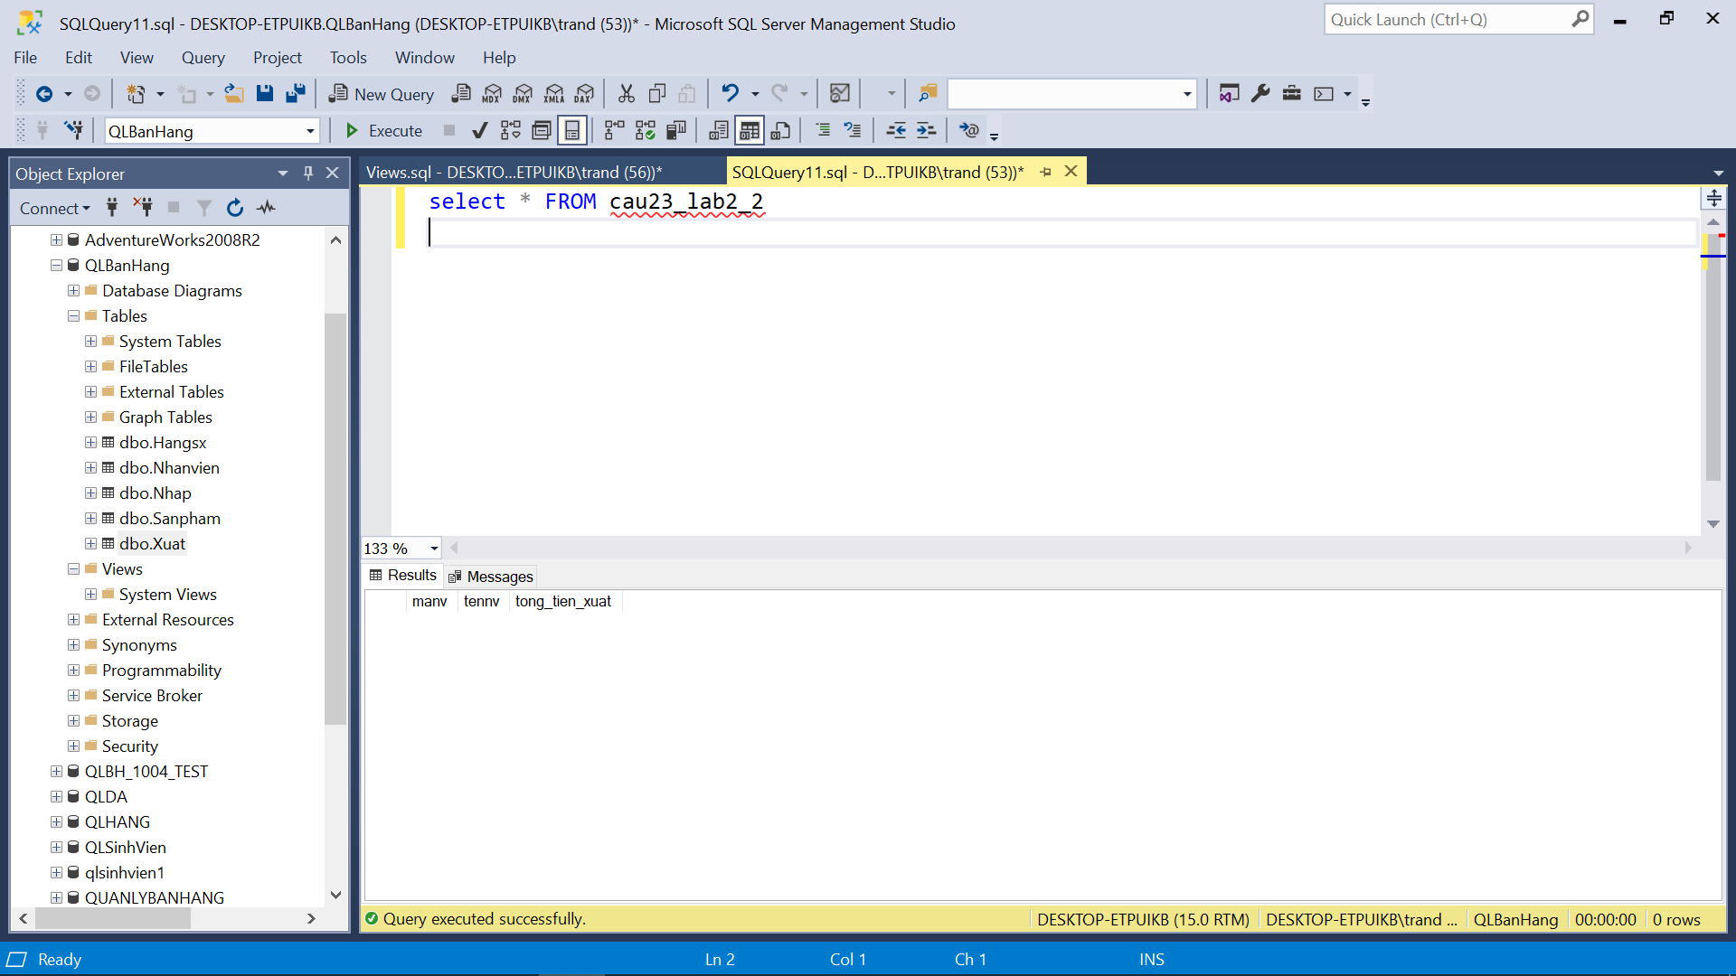

--Câu 24

CREATE VIEW cau24_lab2_2 AS

SELECT manv, SUM(soluongN*dongiaN) as TongTienNhap

FROM Nhap

WHERE MONTH(ngaynhap) = 8 AND YEAR(ngaynhap) = 2018

GROUP BY manv

HAVING SUM(soluongN*dongiaN) > 100000

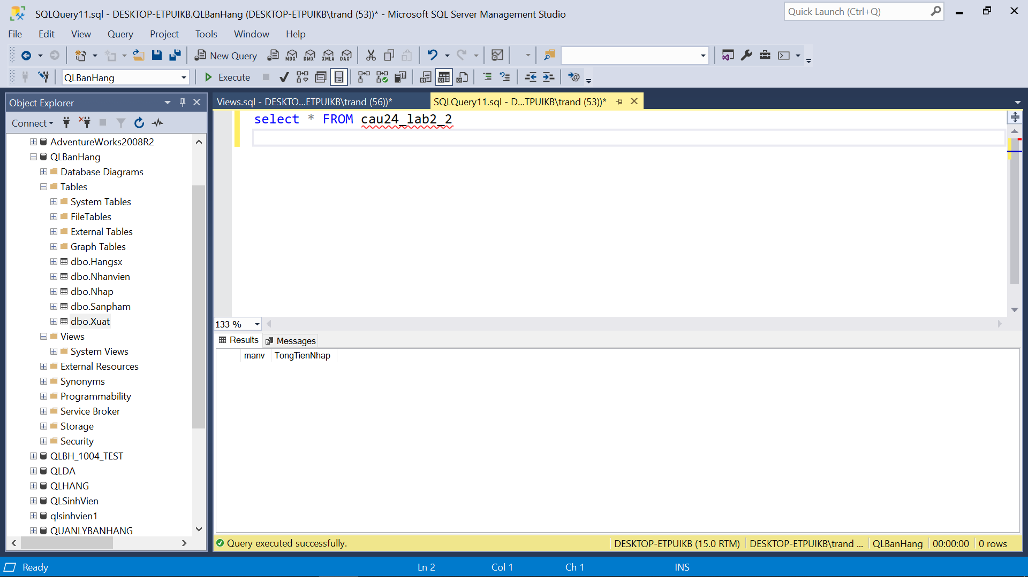

--Câu 25

CREATE VIEW cau25_lab2_2 AS

SELECT *

FROM SanPham

WHERE masp NOT IN (

SELECT masp

FROM Xuat

)

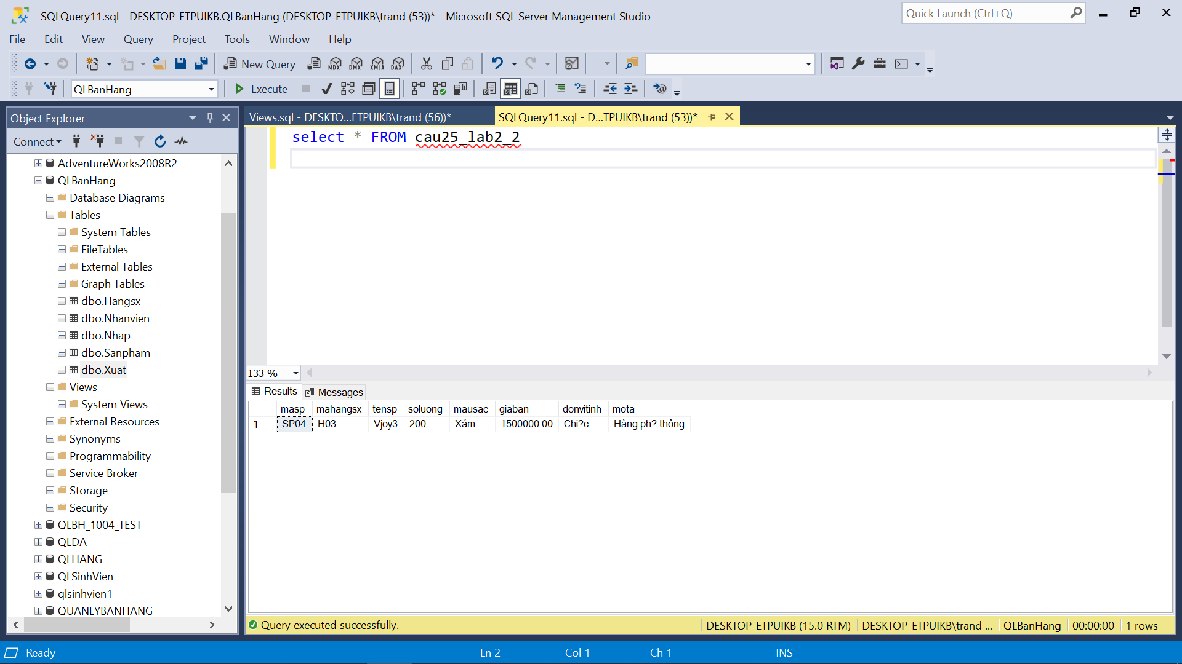

--Câu 26

CREATE VIEW cau26_lab2_2 AS

SELECT sp.*

FROM SanPham sp

INNER JOIN Xuat x ON sp.masp = x.masp

WHERE YEAR(sp.mota) = 2018 AND YEAR(x.ngayxuat) = 2018

--Câu 27

CREATE VIEW cau27_lab2_2 AS

SELECT nv.tennv

FROM Nhap np JOIN Xuat x ON np.manv = x.manv

JOIN Nhanvien nv ON np.manv = nv.manv

GROUP BY nv.manv, NV.tennv

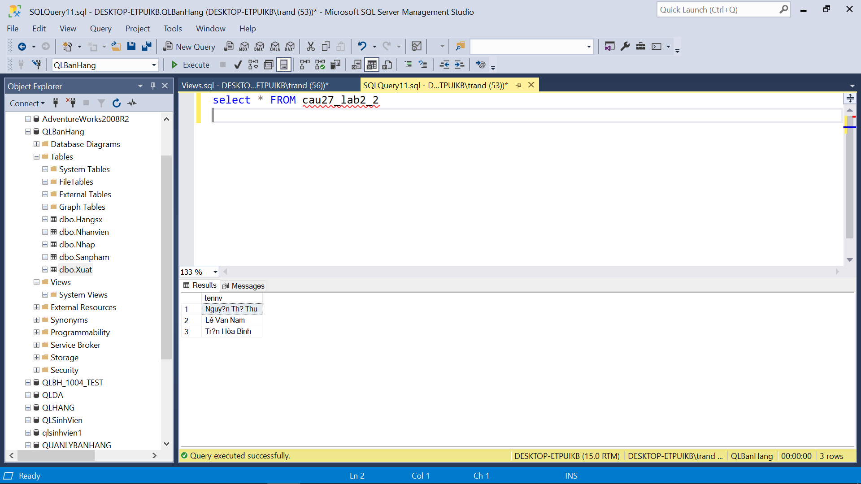

--Câu 28

CREATE VIEW cau28_lab2_2 AS

SELECT tennv

FROM Nhap np JOIN Xuat x ON np.manv = x.manv JOIN Nhanvien nv ON np.manv = nv.manv

WHERE np.manv NOT IN (SELECT DISTINCT manv FROM Nhap)

AND x.manv NOT IN (SELECT DISTINCT manv FROM Xuat)

GROUP BY nv.manv, NV.tennv

